Practical No: 8
Aim: Create MAC protocol simulation implementation for wireless sensor Network.

Steps:
- Take three Laptops one Tablet two smartphones and one Wireless Router WRT 300N.
- Click on Every laptop and change the interface to PT-LAPTOP-NM-1W.

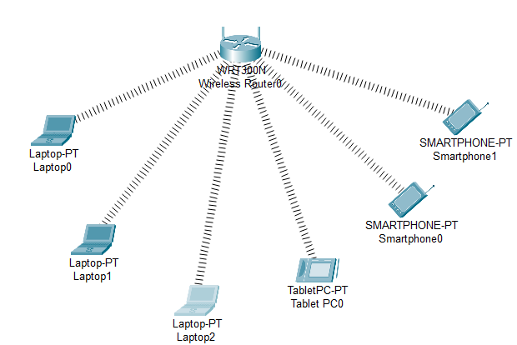

- Click on Laptop0 goto config > wireless and Copy the MAC address and
do the same for every other component as follows.

Laptop:

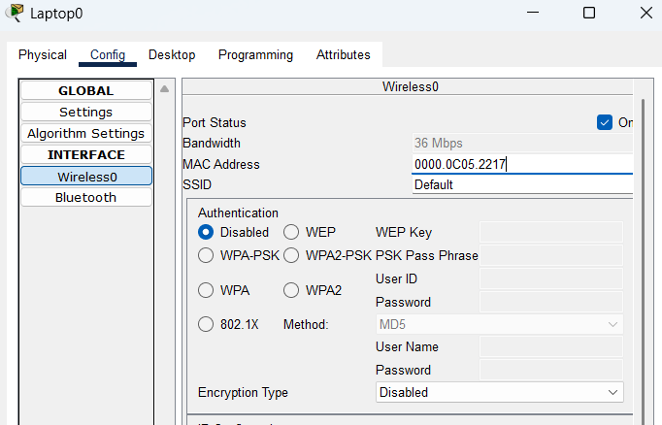

Tablet:

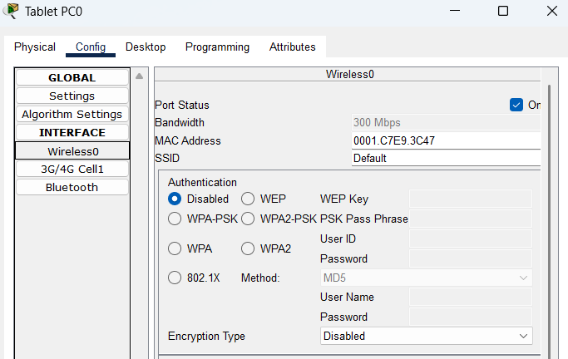

Smart Phone:
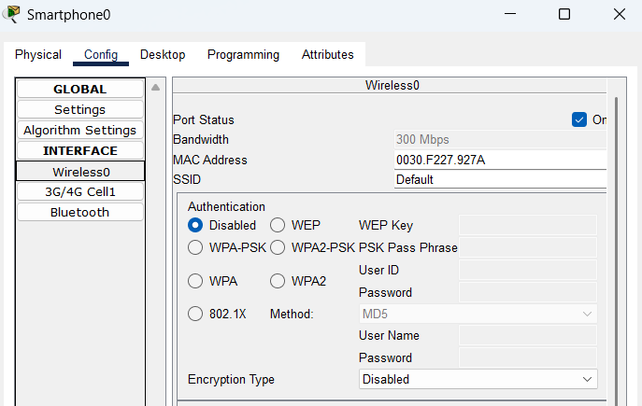

- We note the following MAC addresses and convert them to the following
form:

Component | MAC Address | Converted MAC Address
Laptop0 | 0010.114D.CC80 | 00:10:11:4D:CC:80
Laptop1 | 0060.4752.9ADD | 00:60:47:52:9A:DD
Laptop2 | 00E0.8FDC.A26E | 00:E0:8F:DC:A2:6E
TabletPC | 00D0.9738.E216 | 00:D0:97:38:E2:16
Smartphone0 | 0005.5EA1.D507 | 00:05:5E:A1:D5:07
Smartphone1 | 00D0.D33D.87AC | 00:D0:D3:3D:87:AC

- Click on Wireless router go to GUI > Wireless > Wireless MAC Filter
then add few addresses in the wireless MAC filter of the Wireless Router
and then use the given options for either allow or deny the Wireless access.
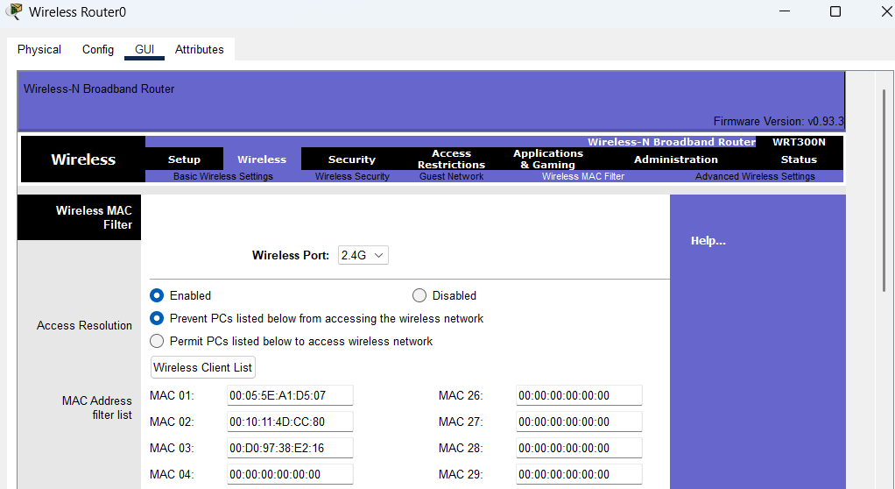

As seen in above screen shot we add the MAC address of Laptop0, TabletPC
SmartPhone0 in the list so as to deny them accessing the Wireless network
and then save the settings.

- Scroll down and click on save Settings.
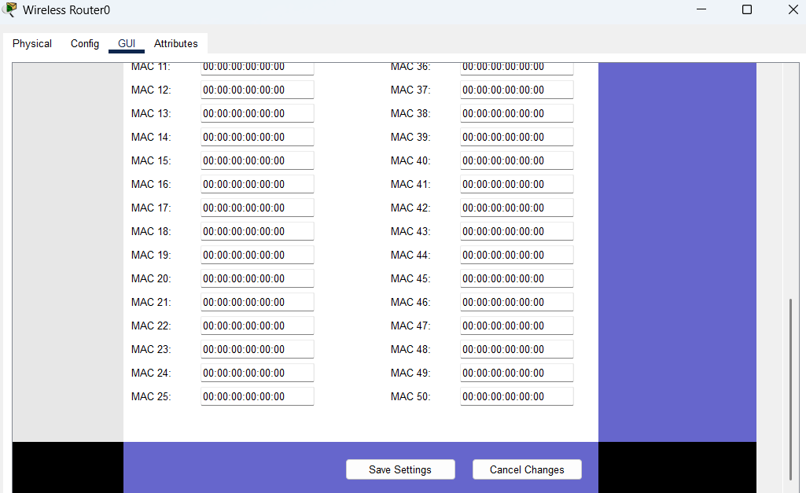

- The result so obtained is as shown, the three devices denied any wireless
connectivity.

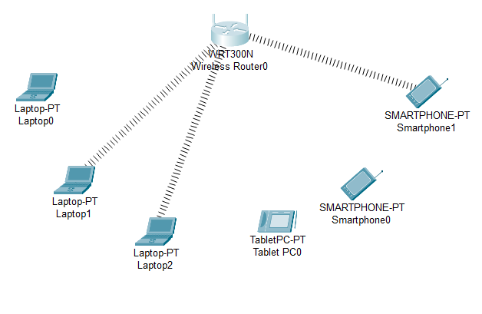
- Similarly we can add or remove the MAC address of components from router to allow or deny connectivity for specific components.
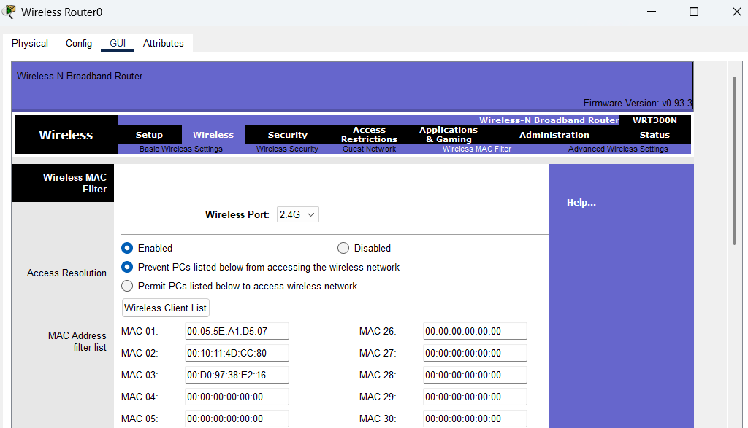

- Click on save settings.

